Fixed-Wing Lesson 1 Introduction to Fixed-wing Flight

[1. What's a Flying Car?](https://classroom.udacity.com/nanodegrees/nd787/parts/ee7d5970-d39c-4355-952e-ce760e701827/modules/2dd61f74-6310-4f18-98b2-e4a9a9450f85/lessons/c239d4a3-8d92-441b-be30-38cccd52e522/concepts/c6f0b3ab-360c-4d6d-8147-31dcaa6612f6)

<https://www.youtube.com/watch?time_continue=8&v=17g4l84E53c>

[2. History of Hybrid Vehicles](https://classroom.udacity.com/nanodegrees/nd787/parts/ee7d5970-d39c-4355-952e-ce760e701827/modules/2dd61f74-6310-4f18-98b2-e4a9a9450f85/lessons/c239d4a3-8d92-441b-be30-38cccd52e522/concepts/c1a3b22c-d949-4d2c-b519-9babdac8772d)

<https://www.youtube.com/watch?v=yayolj-tQkM>

[3. Fixed Wing vs. Rotary Wing Aircraft](https://classroom.udacity.com/nanodegrees/nd787/parts/ee7d5970-d39c-4355-952e-ce760e701827/modules/2dd61f74-6310-4f18-98b2-e4a9a9450f85/lessons/c239d4a3-8d92-441b-be30-38cccd52e522/concepts/1d902f47-9d3c-42fd-b598-9dd71cfff434)

<https://www.youtube.com/watch?v=3YCIT9xUgrQ>

## **Fixed Wing vs. Rotary Wing Aircraft Summary**

Rotary wing aircraft (like quadrotors) and Fixed wing aircraft (like airplanes) **both** have wings which generate lift. On a fixed wing aircraft, the wings are attached to the body of the vehicle. On a rotary wing aircraft, the "wings" are actually the propellers.

These vehicle designs each have advantages and disadvantages.

##### **Advantages of Rotorcraft**

1. **Easy to control** - the dynamics model is often very simple.
2. **They can hover** - this means there are many more feasible plans that a rotorcraft can execute.
3. **Vertical Take Off and Landing (VTOL)** - they don't need a runway!

##### **Disadvantages of Rotorcraft**

1. **Energy inefficient** - this limits their range and payload.
2. **Slow** - compared to fixed wing vehicles, rotorcraft are generally slow.
3. **Loud** - rotorcraft are often noisy.
4. **Useless without power** - if the propellers stop turning, a rotorcraft will fall out of the sky.

#### **Fixed Wing Aircraft**

A fixed wing aircraft has (surprise surprise) wings attached to it. These wings need to be moving through the air to generate lift. Most of the strengths and weaknesses of fixed wing flight stem from this fact.

##### **Tradeoffs**

1. **Efficiency** - A fixed wing vehicle can *glide* through the air without using power! Since lift comes from the motion of the vehicle through the air, a fixed wing vehicle isn't constantly fighting gravity in the same way that a rotorcraft does.
2. **Safety** - This ability to glide means that when the motors fail it's still possible to control the aircraft. That's good! But there's a caveat, since a fixed wing vehicle can't hover (that's bad).
3. **Speed and Payload** - A fixed wing vehicle can spend more of it's thrust on it's forward velocity. This generally means greater speed and larger payloads.

[4. Components of a Fixed Wing Aircraft](https://classroom.udacity.com/nanodegrees/nd787/parts/ee7d5970-d39c-4355-952e-ce760e701827/modules/2dd61f74-6310-4f18-98b2-e4a9a9450f85/lessons/c239d4a3-8d92-441b-be30-38cccd52e522/concepts/50091b1a-1304-4101-8629-daf04e1486fb)

<https://www.youtube.com/watch?v=JHmaNljt8XI>

[5. Components of a Wing](https://classroom.udacity.com/nanodegrees/nd787/parts/ee7d5970-d39c-4355-952e-ce760e701827/modules/2dd61f74-6310-4f18-98b2-e4a9a9450f85/lessons/c239d4a3-8d92-441b-be30-38cccd52e522/concepts/17afb8bc-3aff-404a-9732-731985d478e0)

<https://www.youtube.com/watch?time_continue=1&v=HMlofVBvpGY>

[6. Installing the Fixed Wing Simulator](https://classroom.udacity.com/nanodegrees/nd787/parts/ee7d5970-d39c-4355-952e-ce760e701827/modules/2dd61f74-6310-4f18-98b2-e4a9a9450f85/lessons/c239d4a3-8d92-441b-be30-38cccd52e522/concepts/3484cc91-454b-40df-a58f-1fa04070d544)

# **Fixed Wing Simulator**

The (optional) final project for this course involves writing a controller for a fixed wing aircraft. You don't need to worry about the details of this project right now, but now would be a good time to install the fixed wing simulator you'll be using.

At this point you should:

1. Visit the [github repository for the final project](https://github.com/udacity/FCND-FixedWing) and skim through the instructions so you have a sense for what the final project is.
2. Download the appropriate [fixed wing simulator](https://github.com/udacity/FCND-FixedWing/releases) for your machine.
3. Play around in sandbox mode (there are instructions in the final project repo page for how to do this).
4. Answer the questions below about the control surfaces on a fixed wing vehicle.

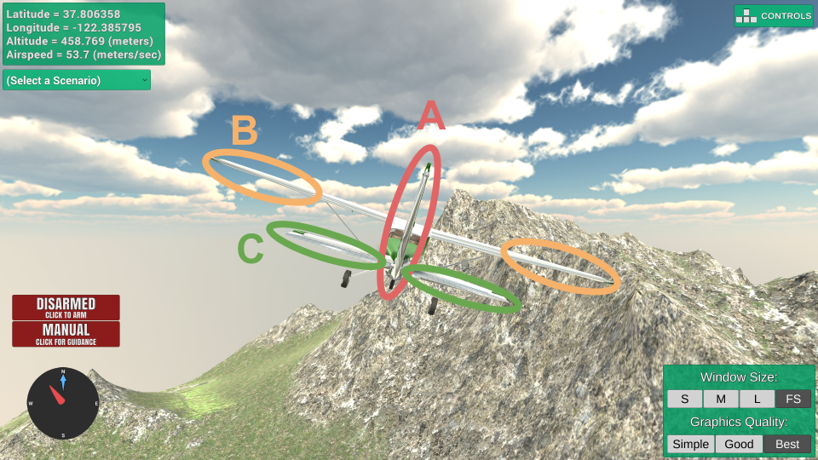

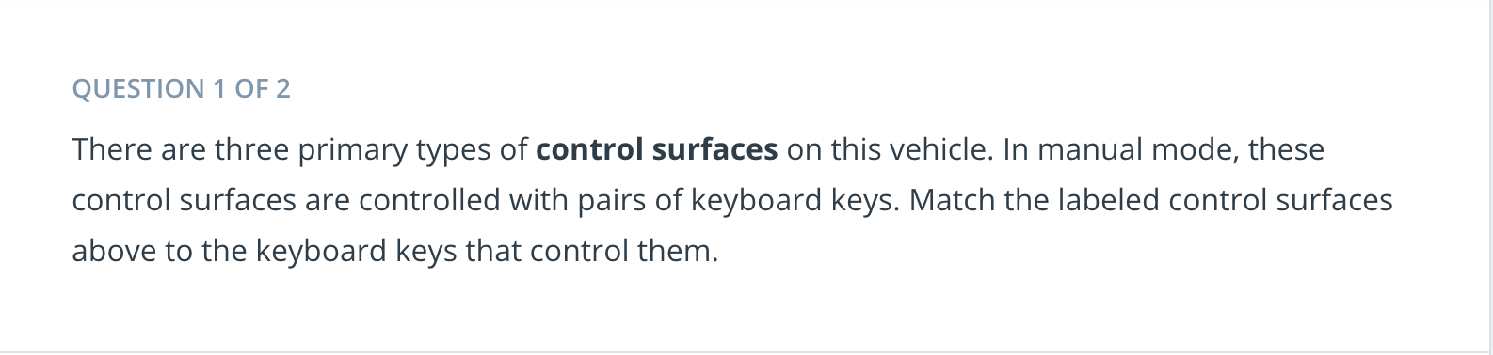

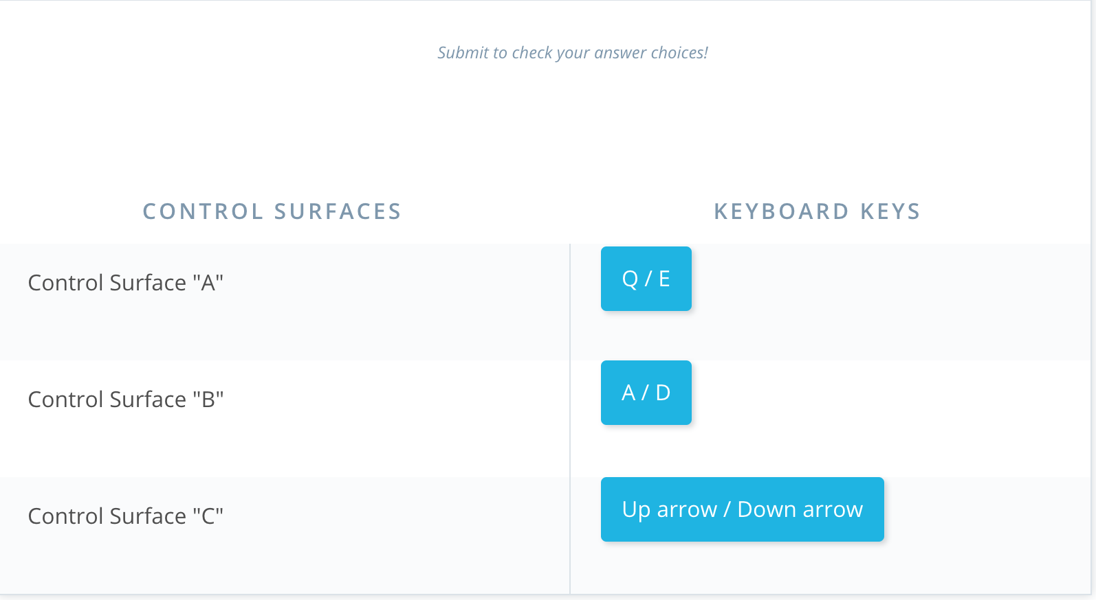

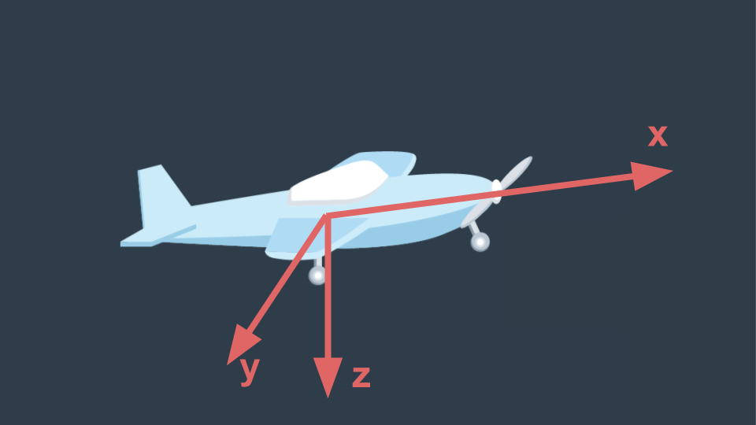

The body frame axes for a fixed wing vehicle are typically defined as shown above. Rotations about each of these axes is given its own name.

* **Roll** is rotation about the **x axis**
* **Pitch** is rotation about the **y axis**
* **Yaw** is rotation about the **z axis**

Each of the three control surfaces is primarily responsible for rotations about **one** of these axes.

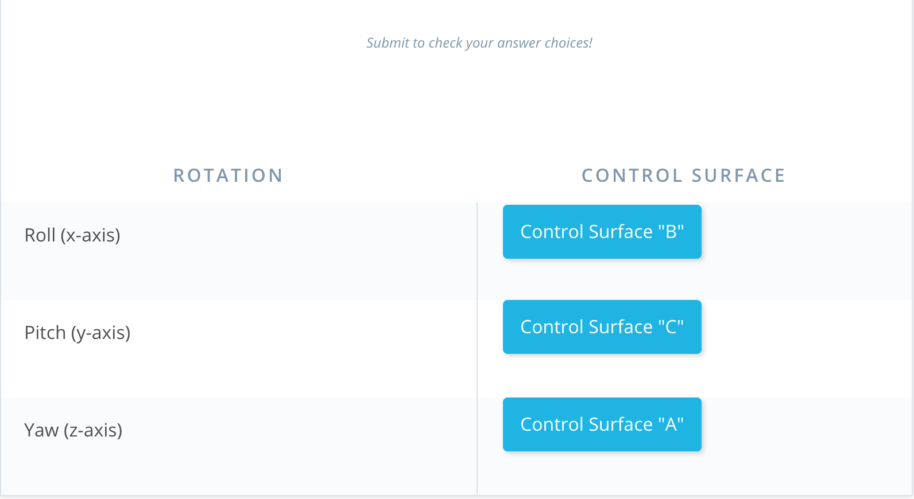

[7. Fixed Wing Control Surfaces](https://classroom.udacity.com/nanodegrees/nd787/parts/ee7d5970-d39c-4355-952e-ce760e701827/modules/2dd61f74-6310-4f18-98b2-e4a9a9450f85/lessons/c239d4a3-8d92-441b-be30-38cccd52e522/concepts/08325e13-93e2-48a8-915b-6c6576b9d5ea)

<https://www.youtube.com/watch?time_continue=2&v=X4q8el9m_Lw>

## **More Control Surfaces**

The ailerons, elevators, and rudder are used to control roll, pitch, and yaw. But these aren't the only control surface you'll find on fixed wing vehicles.

##### **Flaps**

Flaps are mounted on the interior section of each wing and are used to reduce the "stall speed" of an aircraft by increasing the amount of lift the wing generates. They are typically used by commercial jets during take-off and landing.

##### **Spoilers**

Spoilers are used on low-drag aircraft to reduce lift by disrupting airflow. Glider pilots use spoilers when they want to lose altitude without gaining too much speed.

##### **Slats**

Slats are mounted on the leading edge of wings. When deployed, they allow the aircraft to operate at lower speeds.

##### **Air Brakes**

Air brakes slow the aircraft down by increasing drag. Spoilers can act as air brakes, but they *also*reduce lift. Air brakes are often mounted on the side of the fuselage to minimize their effect on lift.

If you'd like to learn more, the [Wikipedia article on Flight control surfaces](https://en.wikipedia.org/wiki/Flight_control_surfaces) has additional information.

[8. Summary](https://classroom.udacity.com/nanodegrees/nd787/parts/ee7d5970-d39c-4355-952e-ce760e701827/modules/2dd61f74-6310-4f18-98b2-e4a9a9450f85/lessons/c239d4a3-8d92-441b-be30-38cccd52e522/concepts/d20548ec-761d-4063-a9e9-da276f2ceedb)

<https://www.youtube.com/watch?v=kYLOA3KdE_k>